MAJOR SCALE WORKSHEET I
Due: Week of 10/5-10/9
- Look at the C major scale below: 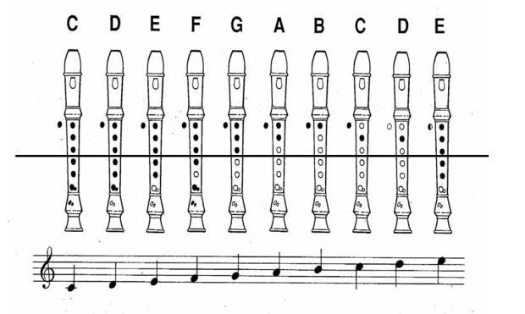
*HINTS* No letter is ever repeated in a major scale.
Draw the notes out first onto the staff then label the letter names.
- Write an ascending C major scale in whole notes. Label the notes.

_____ _____ _____ _____ _____ _____ _____ _____
- Write a descending C major scale in whole notes. Label the notes.

_____ _____ _____ _____ _____ _____ _____ _____
- Write an ascending C major scale in half notes. Label the notes.

_____ _____ _____ _____ _____ _____ _____ _____
- Write a descending C major scale in half notes. Label the notes.

_____ _____ _____ _____ _____ _____ _____ _____

